Solar energy is clean and green energy for providing an excellent solution to complete energy demand. Light harvesting systems like solar cells are important devices for absorbing the light energy and converting that energy into electrical energy. The mostly used light harvesting system for this purpose is

silicon-based solar technology. The silicon-based solar technology is more reliable in the terms of power-conversion efficiency (PCE), stability and life time, but fabricating cost is higher as compared to other PV technologies . The other technologies like thin film solar cells, organic solar cells (OSCs) and dye-sensitized solar cells (DSSCs) are now competing with silicon-based solar technologies to make efficient, stable and low cost solar cells . Material and processing costs limits the commercialization of most of the PV devices. The key solution to this problem is to mimic the biological structures like cyanobacteria or chlorophyll for better harvesting of solar energy to fulfill energy requirements . The advantage of the biomimicry is to have light harvesting devices of low cost material, material abundance and negative carbon footprint . The bioinspired technologies can be inexpensive and ultimate alternative for producing low-cost and efficient PV devices . Photosynthetic bacteria and plants harvest light with high efficiency through special proteins (reaction centers) and convert it into electrochemical energy . The phenomenon

of photosynthesis is so efficient and occurs at incredibly high speeds. The journey of electron takes place through series of specially located pigments to create one-way path. In artificial solar systems like solar cell, the electron can easily bounce back across the junction or membrane due to which it loses its energy and executing the whole process with less efficiency n photosynthesis, excitation energy transfer and charge separation are two ultrafast processes with transfer rate of 10 12 s21. Under most favorable conditions, photon is absorbed by the photosynthetic organism and the electron transfer occurs in the system obeying fundamental quantum mechanics phenomena. These phenomena include delocalization, triggering the charge speed, efficiency and direction of the charge separation process (Barber, 2009). In natural photosynthesis, at least four design principles are possible which can be taken into consideration to mimic the development of bioinspired energy conversion systems. Man made silicon solar cells can convert only 18%25% light into electricity, but plants nearly convert all absorbed light into chemical energy. Diverse sets of optical phenomenon by insects and plants can inspire us to design and develop the much improved solar cells. The inspirations to develop synthetic form of antireflective structures to reduce reflectance loss in solar cells have been taken from the compound eyes of the moths. The synthetic moth eye coated solar panels have showed 33% improvement in efficiency as compared to normal solar cells. In photosynthesis, the antenna complex and photosynthetic reaction center proteins (RCs) perform light harvesting and charge separation. In the DSSC, the antenna complex and RCs are replaced by a dye and semiconductor. Todays’ DSSCs are low-cost solar energy converters, which have reached a power conversion efficiency up to 12% . The primary step in any kind of solar device is light absorption; therefore, maximizing panchromatic light collection is fundamental to improving solar cell efficiency. The three principles relevant to improving light harvesting are light coupling at the initial contact surface, light trapping in weakly absorbed wavelength regions, and the removal of optical losses.

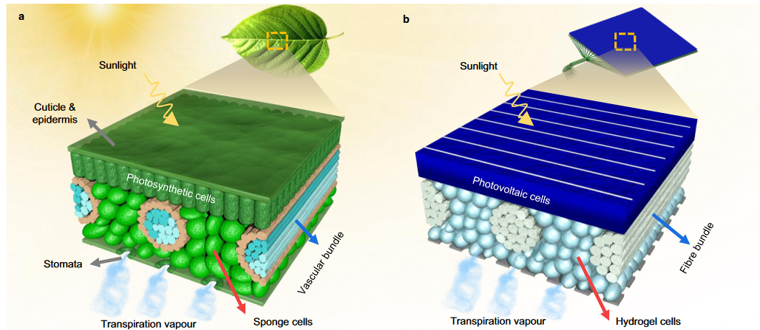

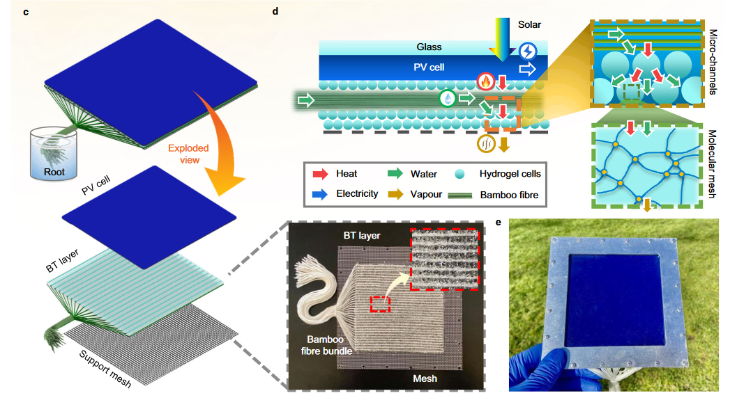

Figure:Schematic illustration of the PV cell and transpiration structure arrangement within the bio-inspired PV-leaf. a Typical internal structure of a real leaf. The vascular bundles uniformly distribute liquid water throughout the whole surface of the leaf. Effective transpiration cooling protects the photosynthetic process. b Internal structure of the bio-inspired transpiration structure. Hydrophilic fibre bundles and hydrogel cells are used to mimic the vascular bundles and sponge cells. c Exploded view of the transpiration structure. The biomimetic transpiration (BT) layer is constructed of bamboo fibre bundles and packed hydrogel cells. The root of the fibre bundles is soaked in bulk water. d Diagram and working principle of the PV-leaf transpiration structure. Water flows from the root to the hydrogel cells driven by capillary and osmotic processes. The water molecules in the molecular mesh then evaporate, removing PV heat. e Photograph of the single PV-leaf prototype.